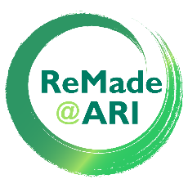
Research Project Description
for ReMade@ARI - A hub for materials research

Please provide a description of the scientific background, the impact on Circular Economy, previous related own research work, the planned experiment including technical and sample description. References should be provided in the online form. This part of the proposal length is limited to max. 3 pages (font size: 11 Calibri).

If you would like advice on techniques or participating facilities before submitting a (pre-)proposal or if you need help filling out the application, talk to the ReMade@ARI Expert Network at sciencesupport@remade-project.eu.

Proposal Ref No.: | PID: XXXXX (taken from portal)
Name of main applicant:
Research Project Title:
Same as online proposal
Scientific background, including the impact of the work on the Circular Economy:
If applicable, previous results on this topic (mainly related to the proposer's work):
Description of the proposed experiment including relevant technical data:
Motivation and justification for access time, chosen techniques, and facility/ies:
Additional information
(Provide any additional information you may feel is helpful)

